EXPERIMENT -5

EXP NO 5: CREATE A SIMPLE CLOUD SOFTWARE APPLICATION FOR LIBRARY BOOK RESERVATION SYSTEM FOR SIMATS LIBRARY USING ANY CLOUD SERVICE PROVIDER TO DEMONSTRATE SAAS

- AIM:
To Create a simple cloud software application for Library book reservation system for SIMATS library using any Cloud Service Provider to demonstrate SaaS

PROCEDURE:
- step1: Go to zoho.com.
- step 2: Log into the zoho.com.
- step 3: Select one application step.
- step4: Enter application name as library book reservation system.
- step 5: Created new application as library book reservation system.
- step 6: Select one form
- step 7: The software has been created.

IMPLEMENTATION:

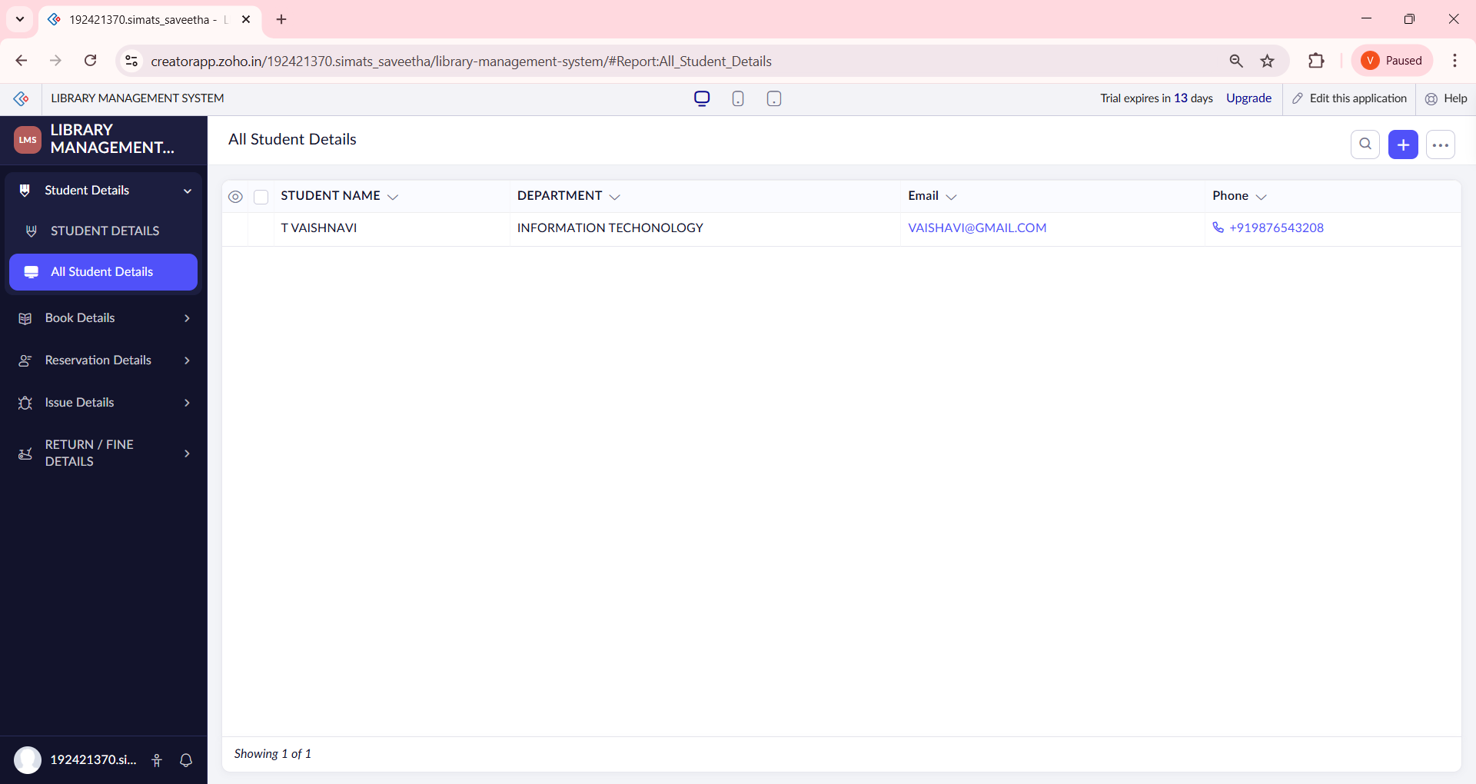

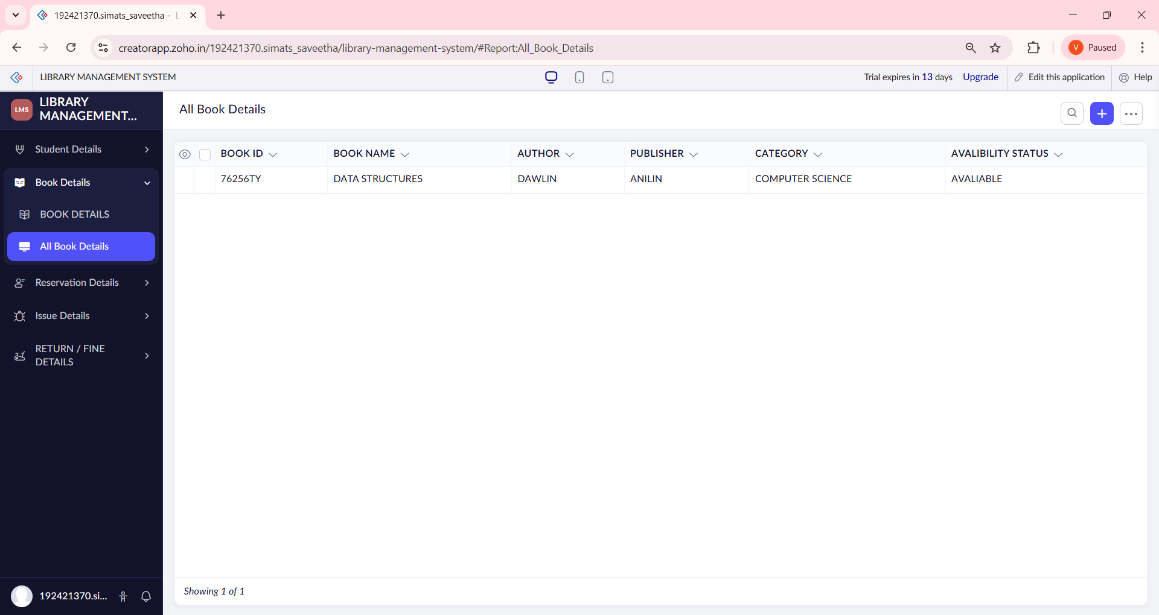

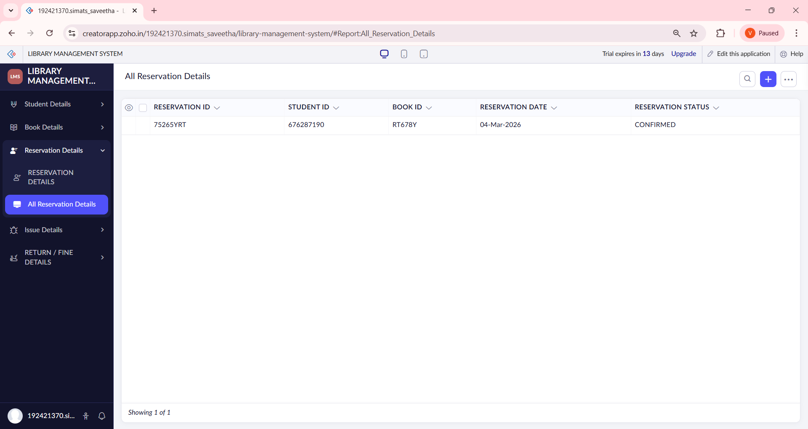
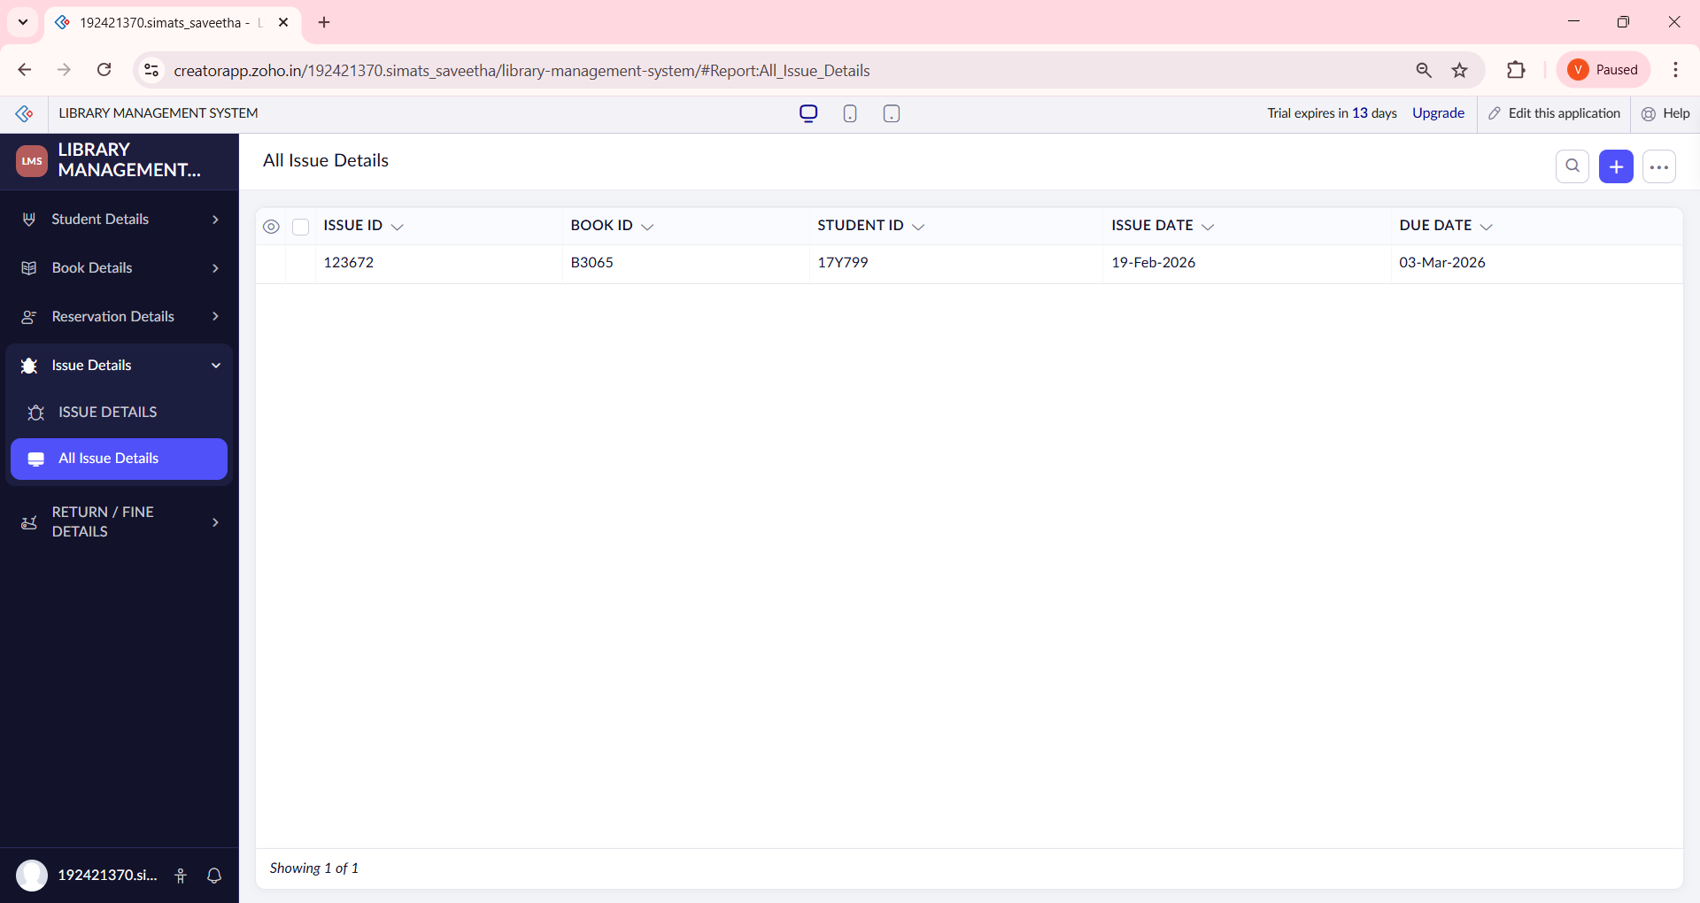

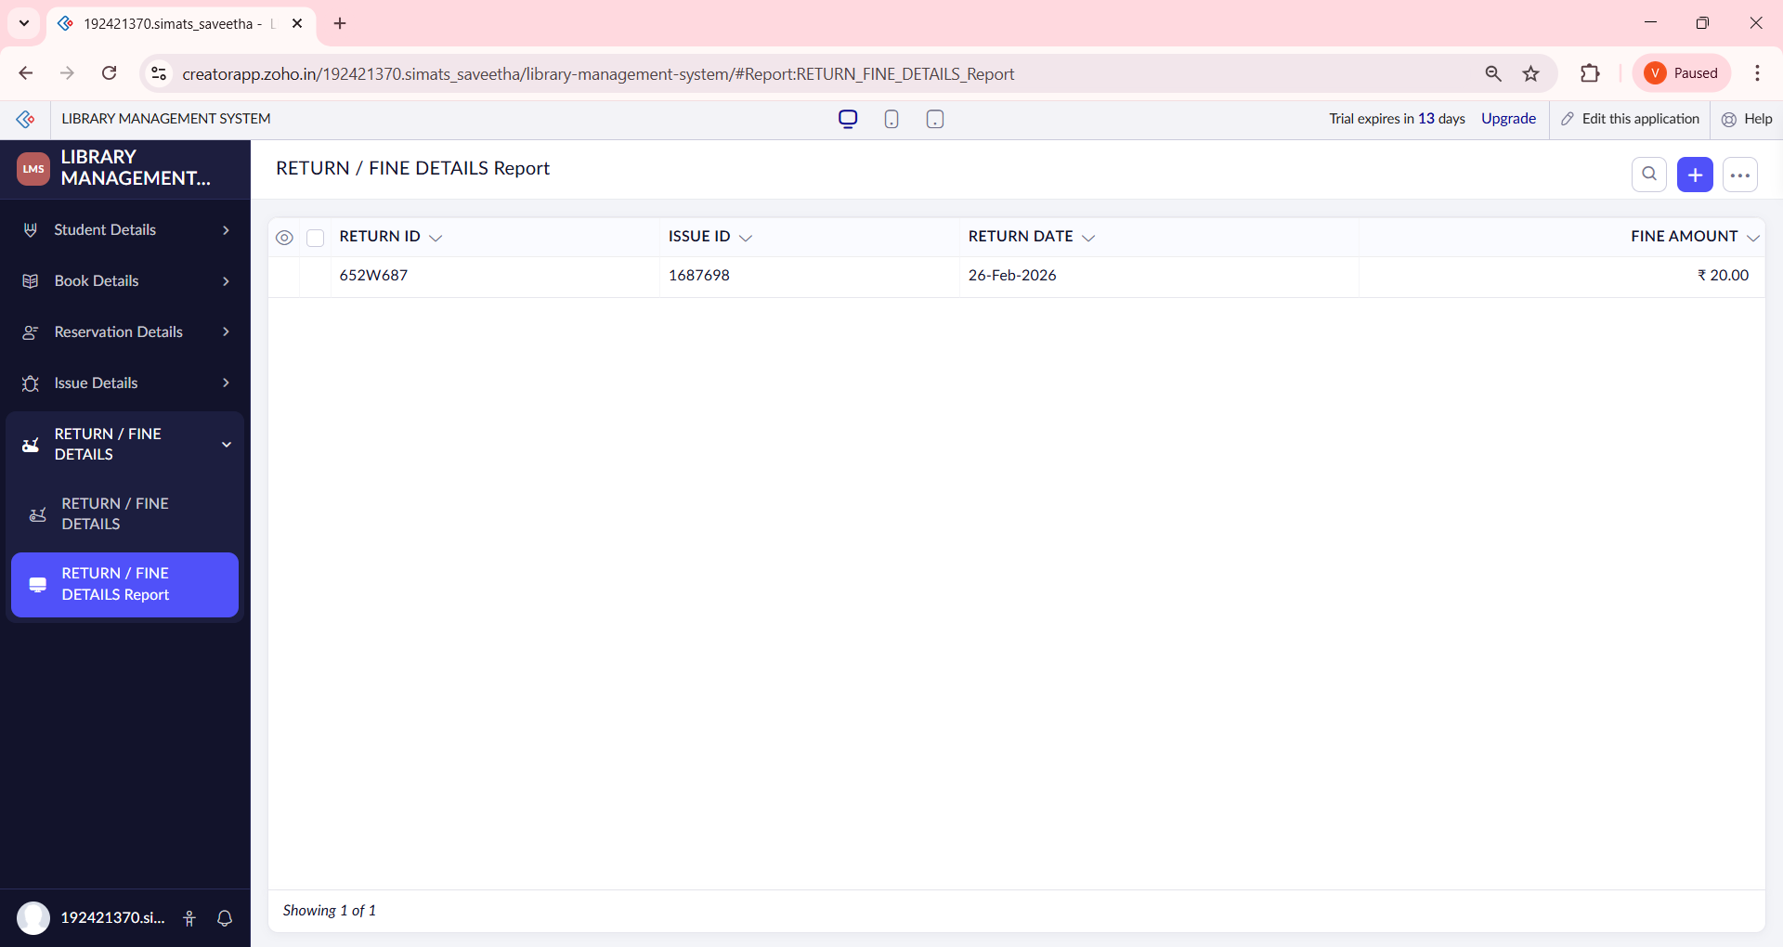

RESULT:
- The Library Book Reservation System for SIMATS Library was successfully created and deployed on the cloud.
- Users can:
  - Enter student details and book information
  - Reserve books online
  - View reserved book details instantly
- Reservation data is stored securely in the cloud database.
- The application can be accessed anytime and anywhere through a web browser.
- No software installation is required by users.
📌 Hence, the application successfully demonstrates Software as a Service (SaaS).

